
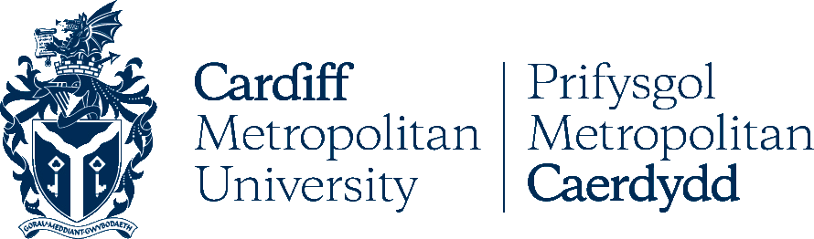
This is to certify that:

And Cardiff Metropolitan University collaborate in relation to the facilitation of advanced entry to a relevant university degree course based on Accredited Prior Learning at LTTC.

* Students must meet all entry requirements as stated in MOA.

Cardiff Metropolitan University Ly Tu Trong Technical College of HCMC
Signature Signature

Date: 25th February 2016

Ly Tu Trong Technical College
of Ho Chi Minh City (LTTC)

